**MongoDB Query**

1. Find all the information about each products

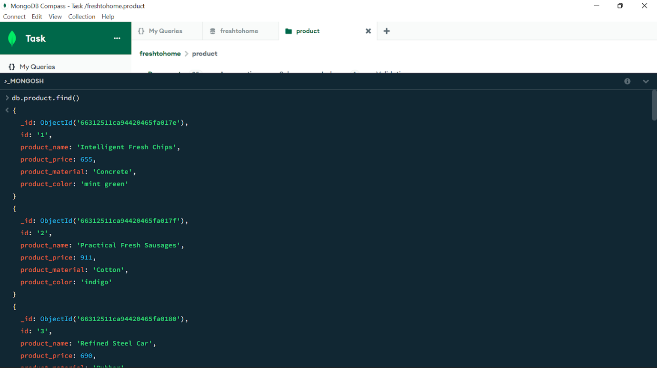

**db.product.find()**

**{**

**_id: ObjectId(**'66312511ca94420465fa017e'**),**

**id:** '1'**,**

**product_name:** 'Intelligent Fresh Chips'**,**

**product_price: 655,**

**product_material:** 'Concrete'**,**

**product_color:** 'mint green'

**}**

**{**

**_id: ObjectId(**'66312511ca94420465fa017f'**),**

**id:** '2'**,**

**product_name:** 'Practical Fresh Sausages'**,**

**product_price: 911,**

**product_material:** 'Cotton'**,**

**product_color:** 'indigo'

**}**

**{**

**_id: ObjectId(**'66312511ca94420465fa0180'**),**

**id:** '3'**,**

**product_name:** 'Refined Steel Car'**,**

**product_price: 690,**

**product_material:** 'Rubber'**,**

**product_color:** 'gold'

**}**

**{**

**_id: ObjectId(**'66312511ca94420465fa0181'**),**

**id:** '4'**,**

**product_name:** 'Gorgeous Plastic Pants'**,**

**product_price: 492,**

**product_material:** 'Soft'**,**

**product_color:** 'plum'

**}**

**{**

**_id: ObjectId(**'66312511ca94420465fa0182'**),**

**id:** '5'**,**

**product_name:** 'Sleek Cotton Chair'**,**

**product_price: 33,**

**product_material:** 'Fresh'**,**

**product_color:** 'black'

**}**

**{**

**_id: ObjectId(**'66312511ca94420465fa0183'**),**

**id:** '6'**,**

**product_name:** 'Awesome Wooden Towels'**,**

**product_price: 474,**

**product_material:** 'Plastic'**,**

**product_color:** 'orange'

**}**

**{**

**_id: ObjectId(**'66312511ca94420465fa0184'**),**

**id:** '7'**,**

**product_name:** 'Practical Soft Shoes'**,**

**product_price: 500,**

**product_material:** 'Rubber'**,**

**product_color:** 'pink'

**}**

**{**

**_id: ObjectId(**'66312511ca94420465fa0185'**),**

**id:** '8'**,**

**product_name:** 'Incredible Steel Hat'**,**

**product_price: 78,**

**product_material:** 'Rubber'**,**

**product_color:** 'violet'

**}**

**{**

**_id: ObjectId(**'66312511ca94420465fa0186'**),**

**id:** '9'**,**

**product_name:** 'Awesome Wooden Ball'**,**

**product_price: 28,**

**product_material:** 'Soft'**,**

**product_color:** 'azure'

**}**

**{**

**_id: ObjectId(**'66312511ca94420465fa0187'**),**

**id:** '10'**,**

**product_name:** 'Generic Wooden Pizza'**,**

**product_price: 84,**

**product_material:** 'Frozen'**,**

**product_color:** 'indigo'

**}**

**{**

**_id: ObjectId(**'66312511ca94420465fa0188'**),**

**id:** '11'**,**

**product_name:** 'Unbranded Wooden Cheese'**,**

**product_price: 26,**

**product_material:** 'Soft'**,**

**product_color:** 'black'

**}**

**{**

**_id: ObjectId(**'66312511ca94420465fa0189'**),**

**id:** '12'**,**

**product_name:** 'Unbranded Plastic Salad'**,**

**product_price: 89,**

**product_material:** 'Wooden'**,**

**product_color:** 'pink'

**}**

**{**

**_id: ObjectId(**'66312511ca94420465fa018a'**),**

**id:** '13'**,**

**product_name:** 'Gorgeous Cotton Keyboard'**,**

**product_price: 37,**

**product_material:** 'Concrete'**,**

**product_color:** 'sky blue'

**}**

**{**

**_id: ObjectId(**'66312511ca94420465fa018b'**),**

**id:** '14'**,**

**product_name:** 'Incredible Steel Shirt'**,**

**product_price: 54,**

**product_material:** 'Metal'**,**

**product_color:** 'white'

**}**

**{**

**_id: ObjectId(**'66312511ca94420465fa018c'**),**

**id:** '15'**,**

**product_name:** 'Ergonomic Cotton Hat'**,**

**product_price: 43,**

**product_material:** 'Rubber'**,**

**product_color:** 'mint green'

**}**

**{**

**_id: ObjectId(**'66312511ca94420465fa018d'**),**

**id:** '16'**,**

**product_name:** 'Small Soft Chair'**,**

**product_price: 47,**

**product_material:** 'Cotton'**,**

**product_color:** 'teal'

**}**

**{**

**_id: ObjectId(**'66312511ca94420465fa018e'**),**

**id:** '17'**,**

**product_name:** 'Incredible Metal Car'**,**

**product_price: 36,**

**product_material:** 'Fresh'**,**

**product_color:** 'indigo'

**}**

**{**

**_id: ObjectId(**'66312511ca94420465fa018f'**),**

**id:** '18'**,**

**product_name:** 'Licensed Plastic Bacon'**,**

**product_price: 88,**

**product_material:** 'Steel'**,**

**product_color:** 'yellow'

**}**

**{**

**_id: ObjectId(**'66312511ca94420465fa0190'**),**

**id:** '19'**,**

**product_name:** 'Intelligent Cotton Chips'**,**

**product_price: 46,**

**product_material:** 'Soft'**,**

**product_color:** 'azure'

**}**

**it**

**{**

**_id: ObjectId(**'66312511ca94420465fa0192'**),**

**id:** '21'**,**

**product_name:** 'Unbranded Granite Chicken'**,**

**product_price: 90,**

**product_material:** 'Metal'**,**

**product_color:** 'gold'

**}**

**{**

**_id: ObjectId(**'66312511ca94420465fa0193'**),**

**id:** '22'**,**

**product_name:** 'Ergonomic Soft Hat'**,**

**product_price: 99,**

**product_material:** 'Rubber'**,**

**product_color:** 'black'

**}**

**{**

**_id: ObjectId(**'66312511ca94420465fa0194'**),**

**id:** '23'**,**

**product_name:** 'Intelligent Steel Pizza'**,**

**product_price: 95,**

**product_material:** 'Cotton'**,**

**product_color:** 'azure'

**}**

**{**

**_id: ObjectId(**'66312511ca94420465fa0195'**),**

**id:** '24'**,**

**product_name:** 'Tasty Rubber Cheese'**,**

**product_price: 47,**

**product_material:** 'Frozen'**,**

**product_color:** 'orchid'

**}**

**{**

**_id: ObjectId('66312511ca94420465fa0196'),**

**id: '25',**

**product_name: 'Licensed Steel Car',**

**product_price: 20,**

**product_material: 'Cotton',**

**product_color: 'indigo'**

**}**

  2.Find the product price which are between 400 to 800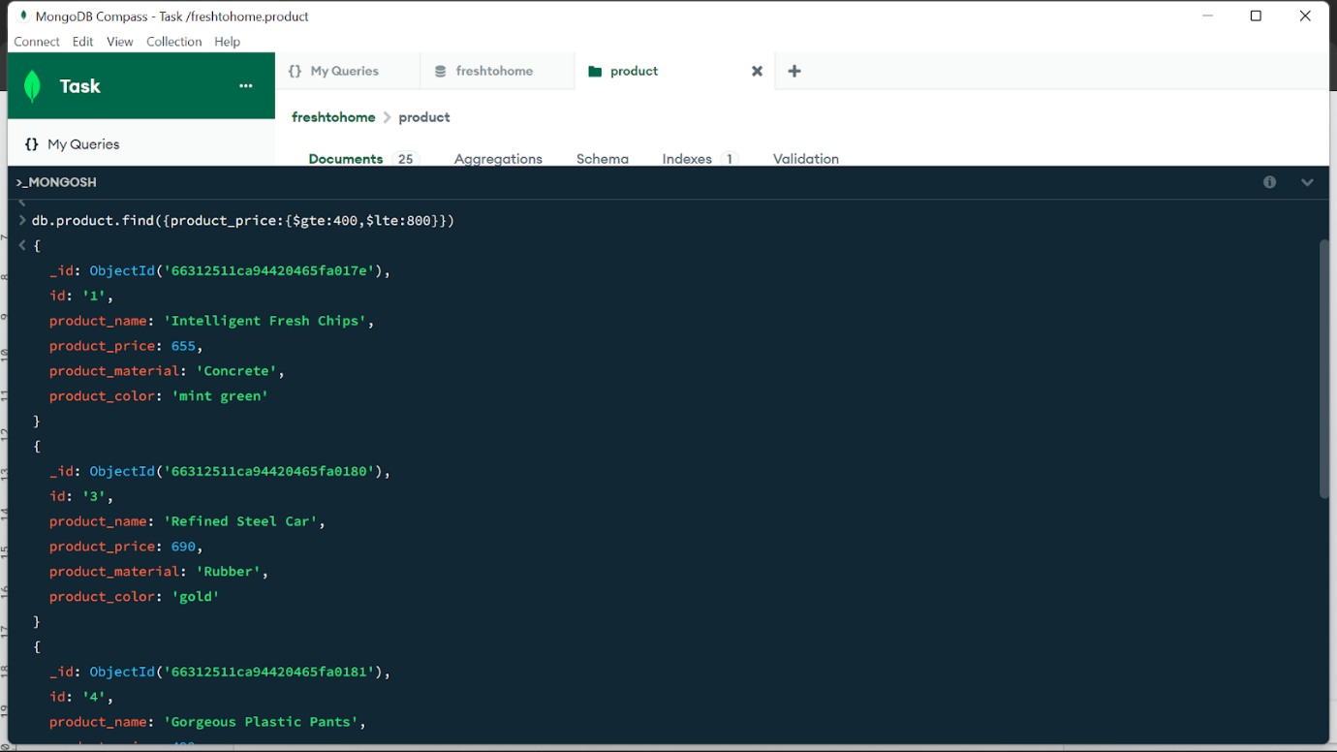

db.product.find({product_price:{$gte:400,$lte:800}})

{

 _id: ObjectId('66312511ca94420465fa017e'),

 id: '1',

 product_name: 'Intelligent Fresh Chips',

 product_price: 655,

 product_material: 'Concrete',

 product_color: 'mint green'

}

{

 _id: ObjectId('66312511ca94420465fa0180'),

 id: '3',

 product_name: 'Refined Steel Car',

 product_price: 690,

 product_material: 'Rubber',

 product_color: 'gold'

}

{

 _id: ObjectId('66312511ca94420465fa0181'),

 id: '4',

 product_name: 'Gorgeous Plastic Pants',

 product_price: 492,

 product_material: 'Soft',

 product_color: 'plum'

}

{

 _id: ObjectId('66312511ca94420465fa0183'),

 id: '6',

 product_name: 'Awesome Wooden Towels',

 product_price: 474,

 product_material: 'Plastic',

 product_color: 'orange'

3.Find the product price which are not between 400 to 600

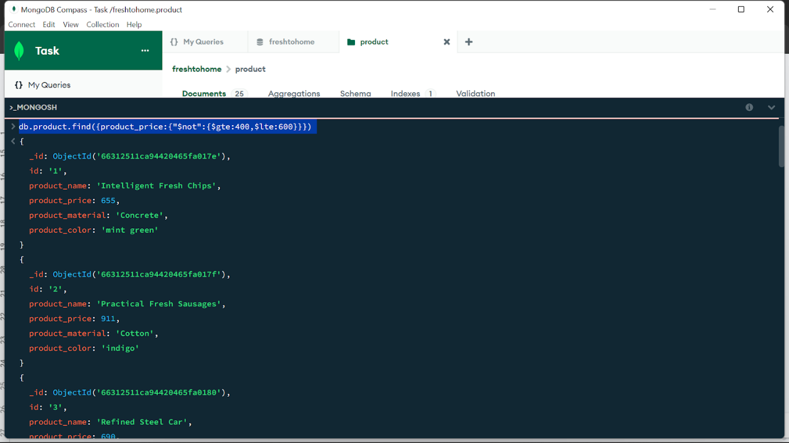

db.product.find({product_price:{"$not":{$gte:400,$lte:600}}})

{

 _id: ObjectId('66312511ca94420465fa017e'),

 id: '1',

 product_name: 'Intelligent Fresh Chips',

 product_price: 655,

 product_material: 'Concrete',

 product_color: 'mint green'

}

{

 _id: ObjectId('66312511ca94420465fa017f'),

 id: '2',

 product_name: 'Practical Fresh Sausages',

 product_price: 911,

 product_material: 'Cotton',

 product_color: 'indigo'

}

{

 _id: ObjectId('66312511ca94420465fa0180'),

 id: '3',

 product_name: 'Refined Steel Car',

 product_price: 690,

 product_material: 'Rubber',

 product_color: 'gold'

}

{

 _id: ObjectId('66312511ca94420465fa0182'),

 id: '5',

 product_name: 'Sleek Cotton Chair',

 product_price: 33,

 product_material: 'Fresh',

 product_color: 'black'

}

{

 _id: ObjectId('66312511ca94420465fa0185'),

 id: '8',

 product_name: 'Incredible Steel Hat',

 product_price: 78,

 product_material: 'Rubber',

 product_color: 'violet'

}

{

 _id: ObjectId('66312511ca94420465fa0186'),

 id: '9',

 product_name: 'Awesome Wooden Ball',

 product_price: 28,

 product_material: 'Soft',

 product_color: 'azure'

}

{

 _id: ObjectId('66312511ca94420465fa0187'),

 id: '10',

 product_name: 'Generic Wooden Pizza',

 product_price: 84,

 product_material: 'Frozen',

 product_color: 'indigo'

}

{

 _id: ObjectId('66312511ca94420465fa0188'),

 id: '11',

 product_name: 'Unbranded Wooden Cheese',

 product_price: 26,

 product_material: 'Soft',

 product_color: 'black'

}

{

 _id: ObjectId('66312511ca94420465fa0189'),

 id: '12',

 product_name: 'Unbranded Plastic Salad',

 product_price: 89,

 product_material: 'Wooden',

 product_color: 'pink'

}

{

 _id: ObjectId('66312511ca94420465fa018a'),

 id: '13',

 product_name: 'Gorgeous Cotton Keyboard',

 product_price: 37,

 product_material: 'Concrete',

 product_color: 'sky blue'

}

{

 _id: ObjectId('66312511ca94420465fa018b'),

 id: '14',

 product_name: 'Incredible Steel Shirt',

 product_price: 54,

 product_material: 'Metal',

 product_color: 'white'

}

{

 _id: ObjectId('66312511ca94420465fa018c'),

 id: '15',

 product_name: 'Ergonomic Cotton Hat',

 product_price: 43,

 product_material: 'Rubber',

 product_color: 'mint green'

}

{

 _id: ObjectId('66312511ca94420465fa018d'),

 id: '16',

 product_name: 'Small Soft Chair',

 product_price: 47,

 product_material: 'Cotton',

 product_color: 'teal'

}

{

 _id: ObjectId('66312511ca94420465fa018e'),

 id: '17',

 product_name: 'Incredible Metal Car',

 product_price: 36,

 product_material: 'Fresh',

 product_color: 'indigo'

}

{

 _id: ObjectId('66312511ca94420465fa018f'),

 id: '18',

 product_name: 'Licensed Plastic Bacon',

 product_price: 88,

 product_material: 'Steel',

 product_color: 'yellow'

}

{

 _id: ObjectId('66312511ca94420465fa0190'),

 id: '19',

 product_name: 'Intelligent Cotton Chips',

 product_price: 46,

 product_material: 'Soft',

 product_color: 'azure'

}

{

 _id: ObjectId('66312511ca94420465fa0191'),

 id: '20',

 product_name: 'Handcrafted Wooden Bacon',

 product_price: 36,

 product_material: 'Concrete',

 product_color: 'lime'

}

{

 _id: ObjectId('66312511ca94420465fa0192'),

 id: '21',

 product_name: 'Unbranded Granite Chicken',

 product_price: 90,

 product_material: 'Metal',

 product_color: 'gold'

}

{

 _id: ObjectId('66312511ca94420465fa0193'),

 id: '22',

 product_name: 'Ergonomic Soft Hat',

 product_price: 99,

 product_material: 'Rubber',

 product_color: 'black'

}

 _id: ObjectId('66312511ca94420465fa0195'),

 id: '24',

 product_name: 'Tasty Rubber Cheese',

 product_price: 47,

 product_material: 'Frozen',

 product_color: 'orchid'

{

  _id: ObjectId('66312511ca94420465fa0196'),

  id: '25',

  product_name: 'Licensed Steel Car',

  product_price: 20,

  product_material: 'Cotton',

  product_color: 'indigo'

}

4.List the four product which are greater than 500 in price

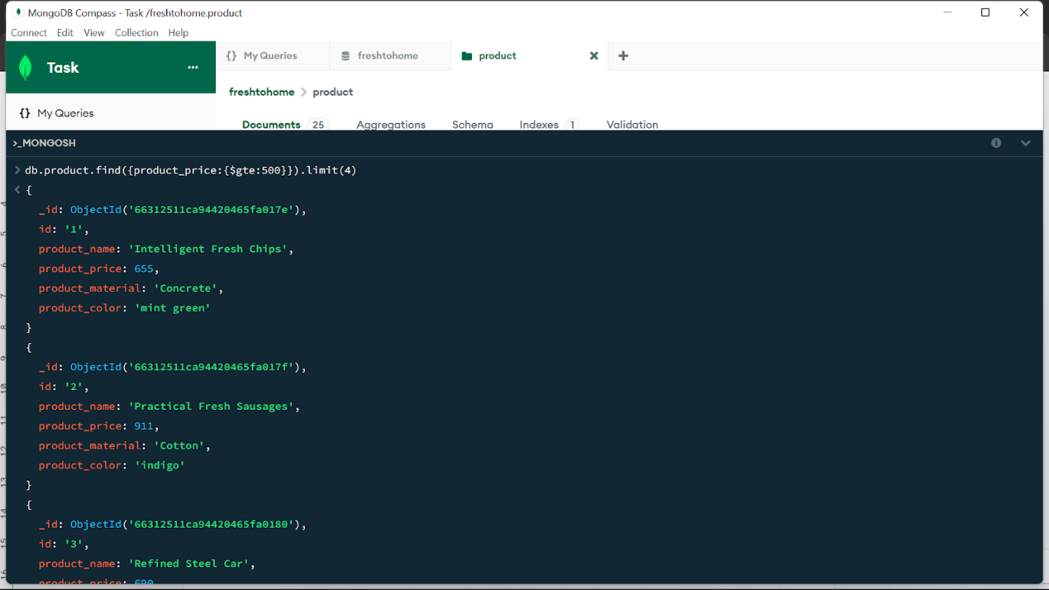

{

db.product.find({product_price:{$gte:500}}).limit(4)

{

 _id: ObjectId('66312511ca94420465fa017e'),

 id: '1',

 product_name: 'Intelligent Fresh Chips',

 product_price: 655,

 product_material: 'Concrete',

 product_color: 'mint green'

}

{

 _id: ObjectId('66312511ca94420465fa017f'),

 id: '2',

 product_name: 'Practical Fresh Sausages',

 product_price: 911,

 product_material: 'Cotton',

 product_color: 'indigo'

}

{

 _id: ObjectId('66312511ca94420465fa0180'),

 id: '3',

 product_name: 'Refined Steel Car',

 product_price: 690,

 product_material: 'Rubber',

 product_color: 'gold'

}

{

  _id: ObjectId('66312511ca94420465fa0184'),

  id: '7',

  product_name: 'Practical Soft Shoes',

  product_price: 500,

  product_material: 'Rubber',

  product_color: 'pink'

}

}

5.Find the product name and product material of each products

}

}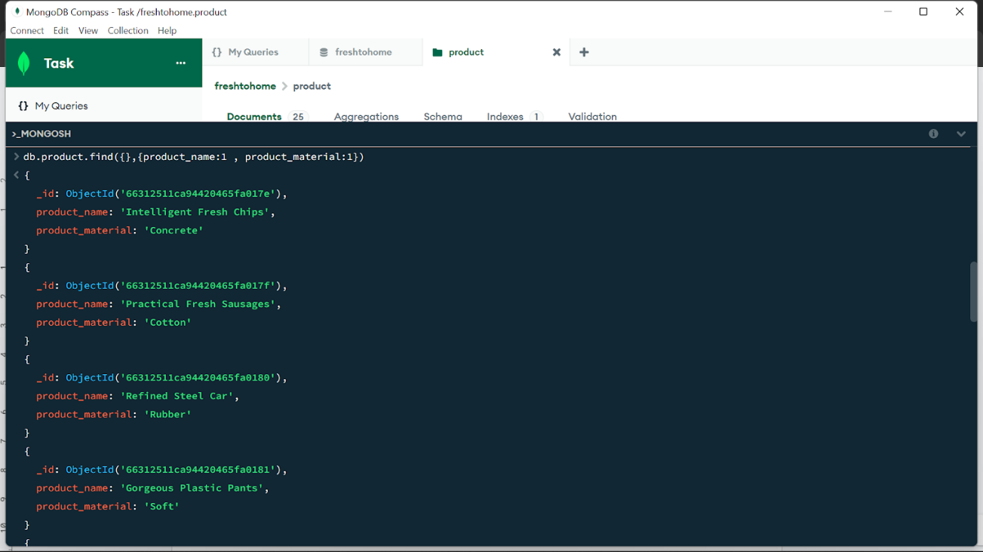

db.product.find({},{product_name:1 , product_material:1})

{

 _id: ObjectId('66312511ca94420465fa017e'),

 product_name: 'Intelligent Fresh Chips',

 product_material: 'Concrete'

}

{

 _id: ObjectId('66312511ca94420465fa017f'),

 product_name: 'Practical Fresh Sausages',

 product_material: 'Cotton'

}

{

 _id: ObjectId('66312511ca94420465fa0180'),

 product_name: 'Refined Steel Car',

 product_material: 'Rubber'

}

{

 _id: ObjectId('66312511ca94420465fa0181'),

 product_name: 'Gorgeous Plastic Pants',

 product_material: 'Soft'

}

{

 _id: ObjectId('66312511ca94420465fa0182'),

 product_name: 'Sleek Cotton Chair',

 product_material: 'Fresh'

}

{

 _id: ObjectId('66312511ca94420465fa0183'),

 product_name: 'Awesome Wooden Towels',

 product_material: 'Plastic'

}

{

 _id: ObjectId('66312511ca94420465fa0184'),

 product_name: 'Practical Soft Shoes',

 product_material: 'Rubber'

}

{

 _id: ObjectId('66312511ca94420465fa0185'),

 product_name: 'Incredible Steel Hat',

 product_material: 'Rubber'

}

{

 _id: ObjectId('66312511ca94420465fa0186'),

 product_name: 'Awesome Wooden Ball',

 product_material: 'Soft'

}

{

 _id: ObjectId('66312511ca94420465fa0187'),

 product_name: 'Generic Wooden Pizza',

 product_material: 'Frozen'

}

{

 _id: ObjectId('66312511ca94420465fa0188'),

 product_name: 'Unbranded Wooden Cheese',

 product_material: 'Soft'

}

{

 _id: ObjectId('66312511ca94420465fa0189'),

 product_name: 'Unbranded Plastic Salad',

 product_material: 'Wooden'

}

{

 _id: ObjectId('66312511ca94420465fa018a'),

 product_name: 'Gorgeous Cotton Keyboard',

 product_material: 'Concrete'

}

{

 _id: ObjectId('66312511ca94420465fa018b'),

 product_name: 'Incredible Steel Shirt',

 product_material: 'Metal'

}

{

 _id: ObjectId('66312511ca94420465fa018c'),

 product_name: 'Ergonomic Cotton Hat',

 product_material: 'Rubber'

}

{

 _id: ObjectId('66312511ca94420465fa018d'),

 product_name: 'Small Soft Chair',

 product_material: 'Cotton'

}

{

 _id: ObjectId('66312511ca94420465fa018e'),

 product_name: 'Incredible Metal Car',

 product_material: 'Fresh'

}

{

 _id: ObjectId('66312511ca94420465fa018f'),

 product_name: 'Licensed Plastic Bacon',

 product_material: 'Steel'

}

{

 _id: ObjectId('66312511ca94420465fa0190'),

 product_name: 'Intelligent Cotton Chips',

 product_material: 'Soft'

{

  _id: ObjectId('66312511ca94420465fa0191'),

  product_name: 'Handcrafted Wooden Bacon',

  product_material: 'Concrete'

}

{

  _id: ObjectId('66312511ca94420465fa0192'),

  product_name: 'Unbranded Granite Chicken',

  product_material: 'Metal'

}

{

  _id: ObjectId('66312511ca94420465fa0193'),

  product_name: 'Ergonomic Soft Hat',

  product_material: 'Rubber'

}

{

  _id: ObjectId('66312511ca94420465fa0194'),

  product_name: 'Intelligent Steel Pizza',

  product_material: 'Cotton'

}

{

  _id: ObjectId('66312511ca94420465fa0195'),

  product_name: 'Tasty Rubber Cheese',

  product_material: 'Frozen'

}

{

  _id: ObjectId('66312511ca94420465fa0195'),

  product_name: 'Tasty Rubber Cheese',

  product_material: 'Frozen'

}

6.Find the product with a row id of 10

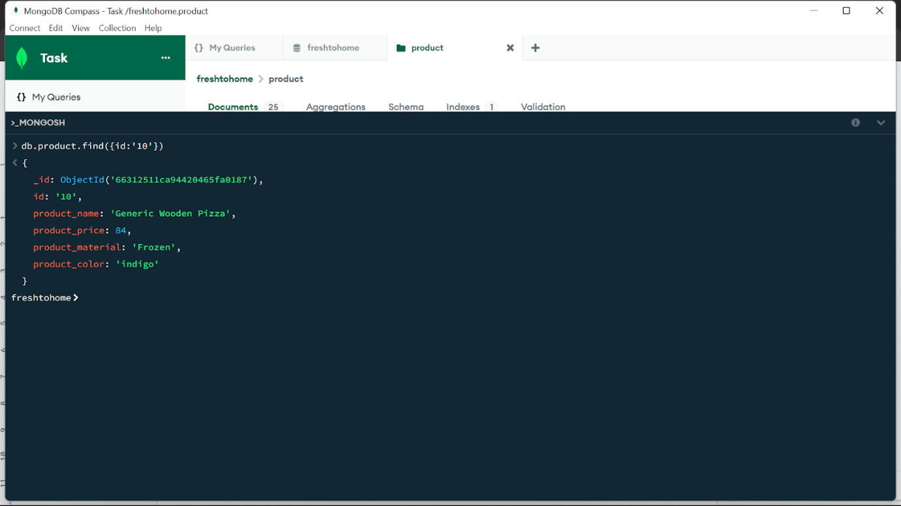

db.product.find({id:'10'})

{

  _id: ObjectId('66312511ca94420465fa0187'),

  id: '10',

  product_name: 'Generic Wooden Pizza',

  product_price: 84,

  product_material: 'Frozen',

  product_color: 'indigo'

7.Find only the product name and product material

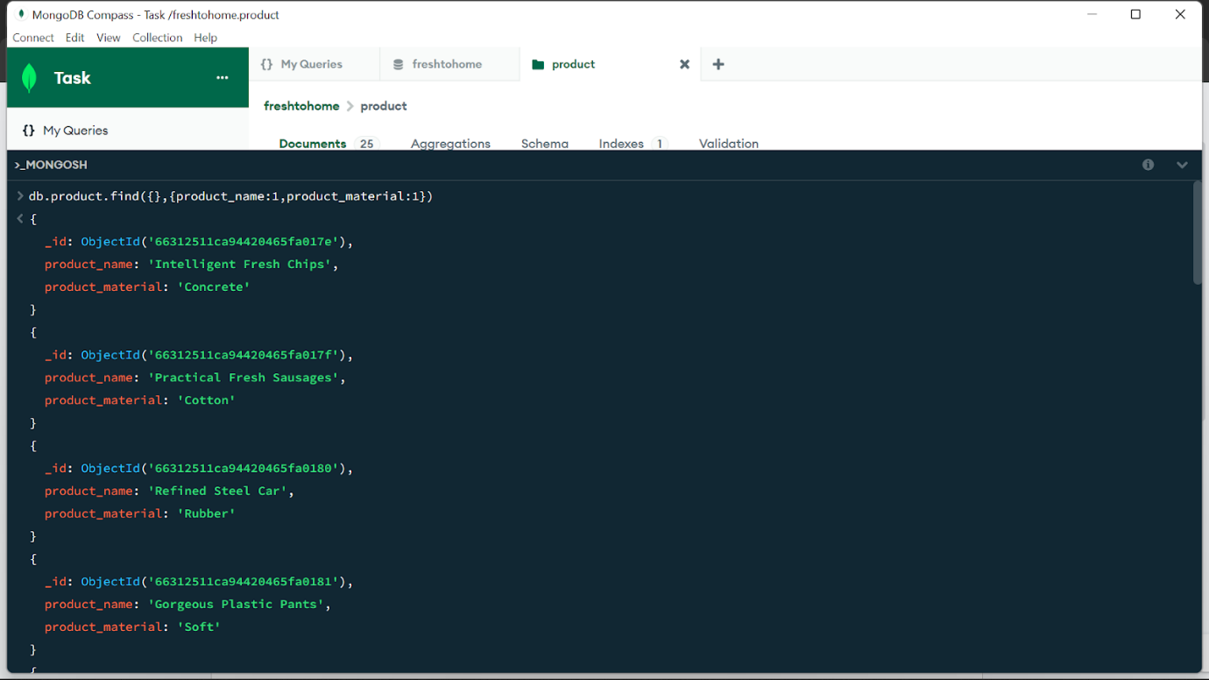

 _id: ObjectId('66312511ca94420465fa017e'),

 product_name: 'Intelligent Fresh Chips',

 product_material: 'Concrete'

}

{

 _id: ObjectId('66312511ca94420465fa017f'),

 product_name: 'Practical Fresh Sausages',

 product_material: 'Cotton'

}

{

 _id: ObjectId('66312511ca94420465fa0180'),

 product_name: 'Refined Steel Car',

 product_material: 'Rubber'

}

{

 _id: ObjectId('66312511ca94420465fa0181'),

 product_name: 'Gorgeous Plastic Pants',

 product_material: 'Soft'

}

{

 _id: ObjectId('66312511ca94420465fa0182'),

 product_name: 'Sleek Cotton Chair',

 product_material: 'Fresh'

}

{

 _id: ObjectId('66312511ca94420465fa0183'),

 product_name: 'Awesome Wooden Towels',

 product_material: 'Plastic'

}

{

 _id: ObjectId('66312511ca94420465fa0184'),

 product_name: 'Practical Soft Shoes',

 product_material: 'Rubber'

}

{

 _id: ObjectId('66312511ca94420465fa0185'),

 product_name: 'Incredible Steel Hat',

 product_material: 'Rubber'

}

{

 _id: ObjectId('66312511ca94420465fa0186'),

 product_name: 'Awesome Wooden Ball',

 product_material: 'Soft'

}

{

 _id: ObjectId('66312511ca94420465fa0187'),

 product_name: 'Generic Wooden Pizza',

 product_material: 'Frozen'

}

{

 _id: ObjectId('66312511ca94420465fa0188'),

 product_name: 'Unbranded Wooden Cheese',

 product_material: 'Soft'

}

{

 _id: ObjectId('66312511ca94420465fa0189'),

 product_name: 'Unbranded Plastic Salad',

 product_material: 'Wooden'

}

{

 _id: ObjectId('66312511ca94420465fa018a'),

 product_name: 'Gorgeous Cotton Keyboard',

 product_material: 'Concrete'

}

{

 _id: ObjectId('66312511ca94420465fa018b'),

 product_name: 'Incredible Steel Shirt',

 product_material: 'Metal'

}

{

 _id: ObjectId('66312511ca94420465fa018c'),

 product_name: 'Ergonomic Cotton Hat',

 product_material: 'Rubber'

}

{

 _id: ObjectId('66312511ca94420465fa018d'),

 product_name: 'Small Soft Chair',

 product_material: 'Cotton'

}

{

 _id: ObjectId('66312511ca94420465fa018e'),

 product_name: 'Incredible Metal Car',

 product_material: 'Fresh'

}

{

 _id: ObjectId('66312511ca94420465fa018f'),

 product_name: 'Licensed Plastic Bacon',

 product_material: 'Steel'

}

{

 _id: ObjectId('66312511ca94420465fa0190'),

 product_name: 'Intelligent Cotton Chips',

 product_material: 'Soft'

{

  _id: ObjectId('66312511ca94420465fa0191'),

  product_name: 'Handcrafted Wooden Bacon',

  product_material: 'Concrete'

}

{

  _id: ObjectId('66312511ca94420465fa0192'),

  product_name: 'Unbranded Granite Chicken',

  product_material: 'Metal'

}

{

  _id: ObjectId('66312511ca94420465fa0193'),

  product_name: 'Ergonomic Soft Hat',

  product_material: 'Rubber'

}

{

  _id: ObjectId('66312511ca94420465fa0194'),

  product_name: 'Intelligent Steel Pizza',

  product_material: 'Cotton'

}

{

  _id: ObjectId('66312511ca94420465fa0195'),

  product_name: 'Tasty Rubber Cheese',

  product_material: 'Frozen'

}

{

  _

8.Find all products which contain the value of soft in product material

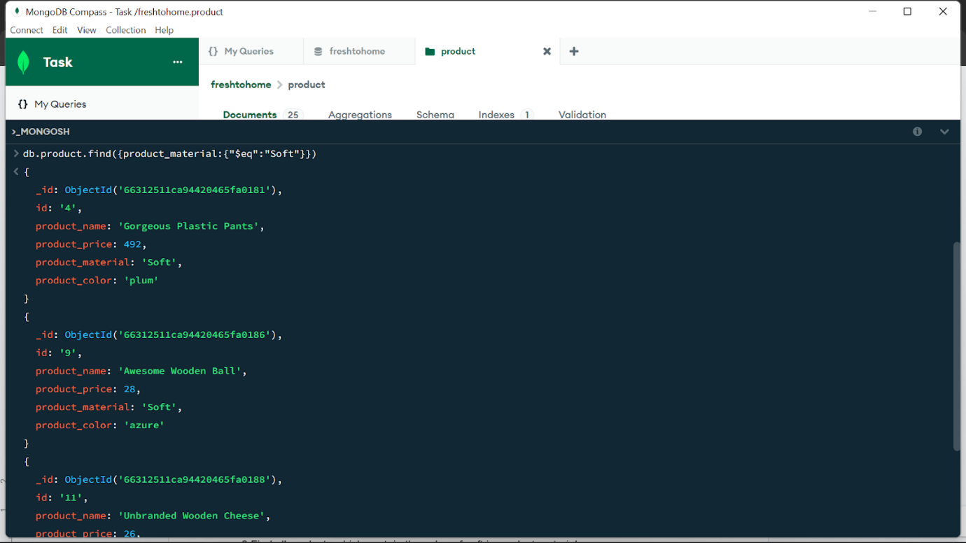

{

  _id: ObjectId('66312511ca94420465fa0181'),

  id: '4',

  product_name: 'Gorgeous Plastic Pants',

  product_price: 492,

  product_material: 'Soft',

  product_color: 'plum'

}

{

  _id: ObjectId('66312511ca94420465fa0186'),

  id: '9',

  product_name: 'Awesome Wooden Ball',

  product_price: 28,

  product_material: 'Soft',

  product_color: 'azure'

}

{

  _id: ObjectId('66312511ca94420465fa0188'),

  id: '11',

  product_name: 'Unbranded Wooden Cheese',

  product_price: 26,

  product_material: 'Soft',

  product_color: 'black'

}

{

  _id: ObjectId('66312511ca94420465fa0190'),

  id: '19',

  product_name: 'Intelligent Cotton Chips',

  product_price: 46,

  product_material: 'Soft',

  product_color: 'azure'

}

9.Find products which contain product color indigo  and product price 492.00

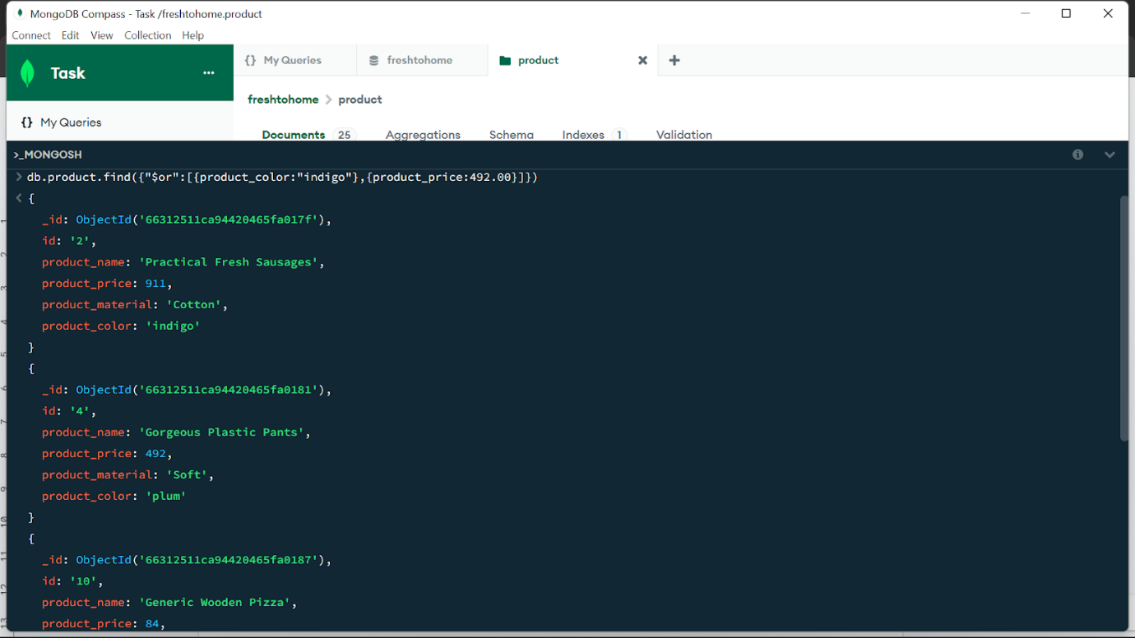

{

  _id: ObjectId('66312511ca94420465fa017f'),

  id: '2',

  product_name: 'Practical Fresh Sausages',

  product_price: 911,

  product_material: 'Cotton',

  product_color: 'indigo'

}

{

  _id: ObjectId('66312511ca94420465fa0181'),

  id: '4',

  product_name: 'Gorgeous Plastic Pants',

  product_price: 492,

  product_material: 'Soft',

  product_color: 'plum'

}

{

  _id: ObjectId('66312511ca94420465fa0187'),

  id: '10',

  product_name: 'Generic Wooden Pizza',

  product_price: 84,

  product_material: 'Frozen',

  product_color: 'indigo'

}

{

  _id: ObjectId('66312511ca94420465fa018e'),

  id: '17',

  product_name: 'Incredible Metal Car',

  product_price: 36,

  product_material: 'Fresh',

  product_color: 'indigo'

}

{

  _id: ObjectId('66312511ca94420465fa0196'),

  id: '25',

  product_name: 'Licensed Steel Car',

  product_price: 20,

  product_material: 'Cotton',

  product_color: 'indigo'

}

10.Delete the products which product price value are 28

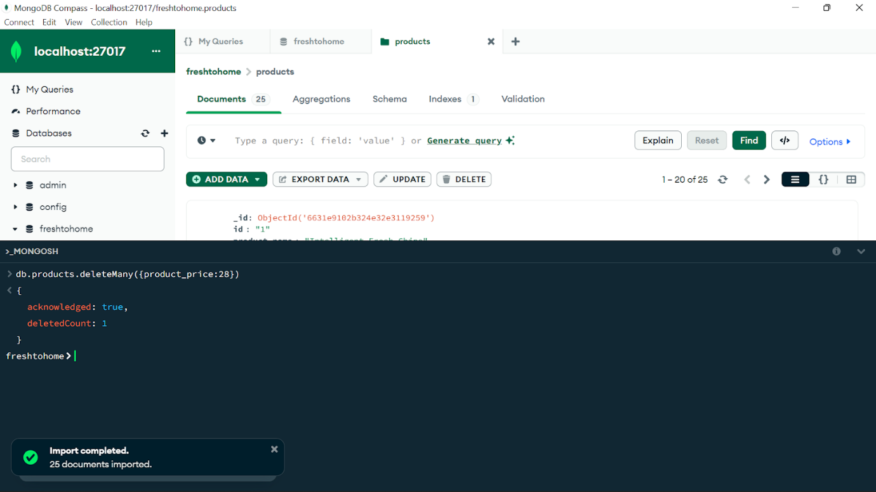

{

  acknowledged: true,

  deletedCount: 1

}